A picture containing clipart

Description generated with very high confidence

NodeJS Module 6

Hands On - 3

[**support@intellipaat.com**](mailto:support@intellipaat.com)

**+91-7022374614**

**US: 1-800-216-8930(Toll Free)**

**NodeJS Module 6: Hands-on: 3**

**Handling Multiple Routes in Express.**

**Step 1:** Open command prompt inside an npm project folder with express installed.

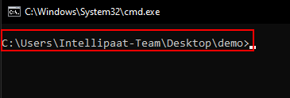

**Step 2:** Create a file named app.js and write the following code in it.

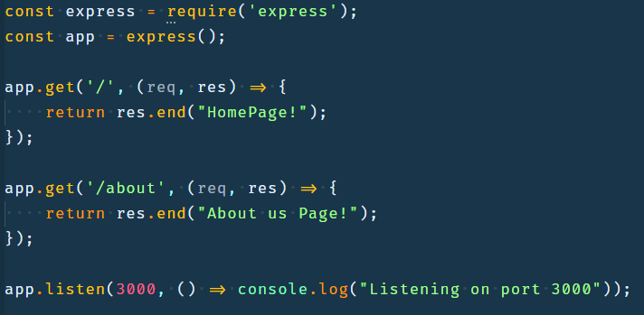

**Step 2.1:** Import the express module using the ‘require’ keyword.

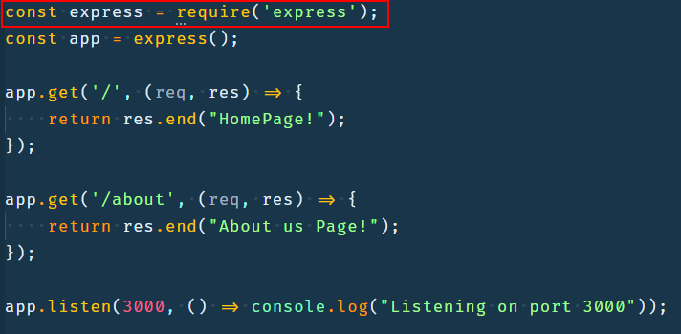

**Step 2.2:** Create an express app by calling the express function imported in previous step.

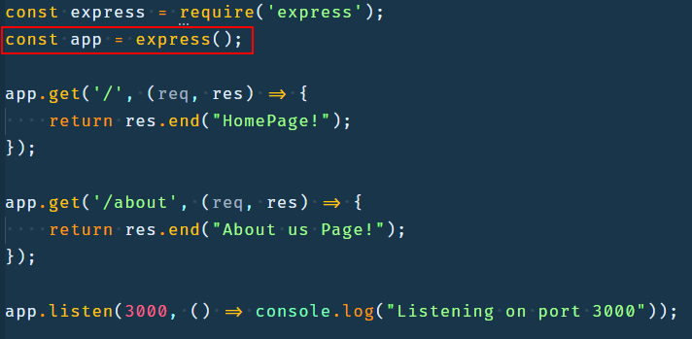

**Step 2.3:** Register a route for a get request to the root url using the app.get method.

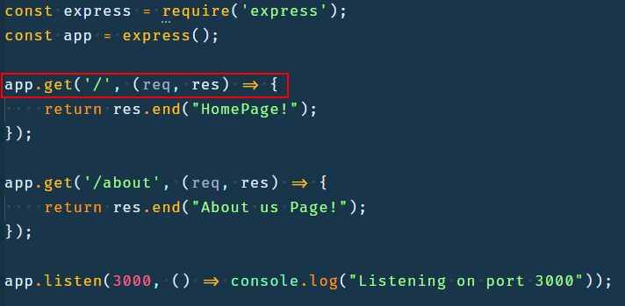

**Step 2.4:** Inside the get method pass ‘/’ to denote root url and a callback that accepts the request and response objects created by express and send back the text HomePage as the response.

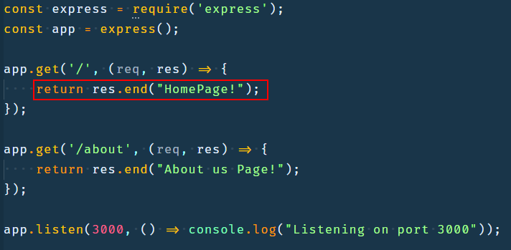

**Step 2.5:** Register a route for a get request to /about url using the app.get method.

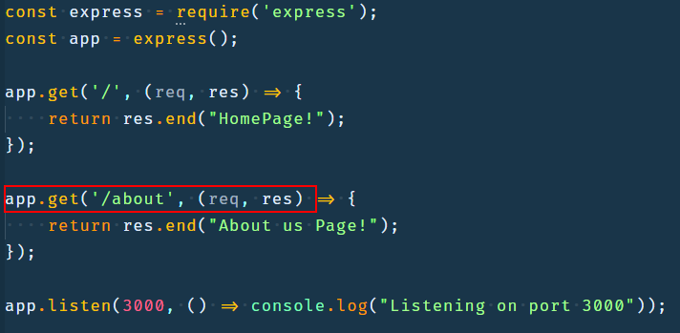

**Step 2.6:** Inside the get method pass ‘/about’ url and a callback that accepts the request and response objects created by express and send back the text `About us Page!` as the response. 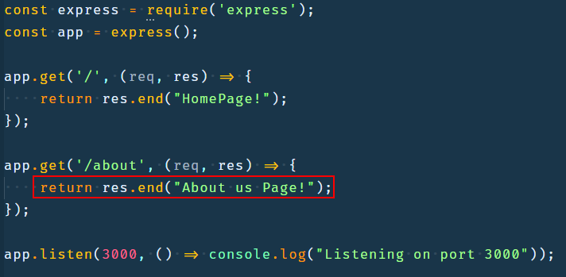

**Step 2.7:** Create a server and listen on port 3000 and print ‘Listening on port 3000’ after server is created using the listen method.

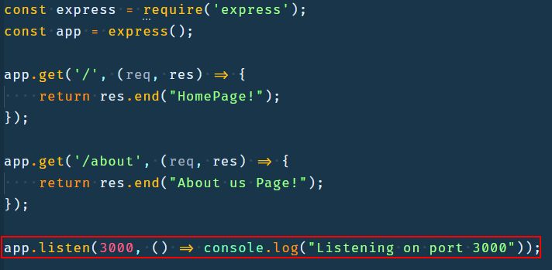

**Step 3:** Open command prompt in the same directory as the file.



**Step 4:** Run the file using the command ‘node app.js’.

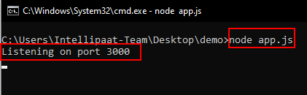

**Step 5:** Open the browser on localhost:3000 and look at the output.

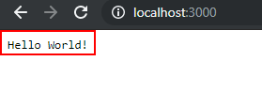

**Step 6:** Open the browser on localhost:3000/about and look at the output.

